Practical Labs04: LockBit

Requirements
- Detect it easy v3.09 (https://github.com/horsicq/DIE-engine/releases)
- OllyDbg
- IDA
- LockBit

Tutorial

Static Analysis
- Let’s check with Detect it easy first. When you check on “Advanced” option on the right, you will see as bellow:
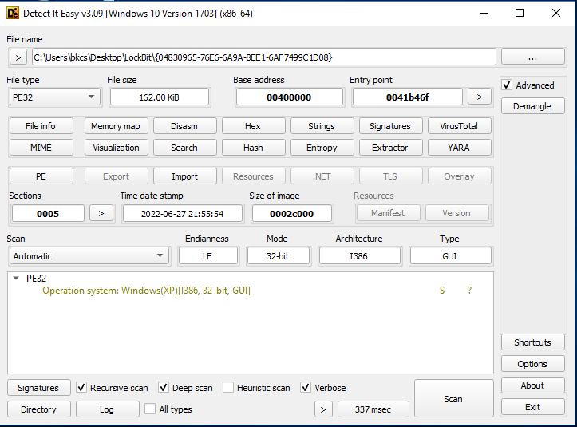
Nothing is special here. Let’s check the “entropy” as bellow. It is packed, and you can see which sections are packed.
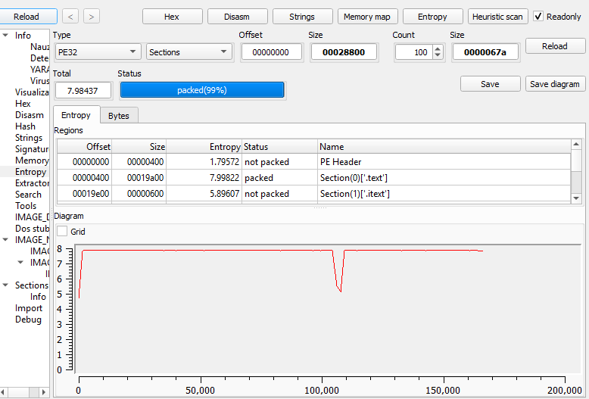
- When we see the “strings”, we can find out this information. There is no valuable strings for analysis:
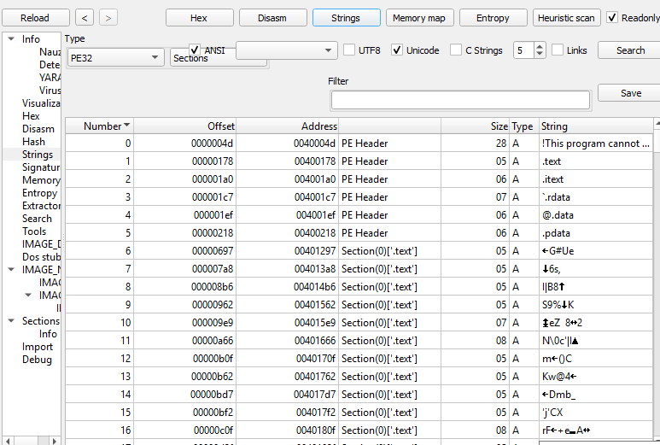
- Let’s check the “Import” to see which API are used. It is packed, so there are only 3 visible DLL files: kernel32, user32 and dgi32. In kernel32.dll, we see API “LoadLibraryExA”.

Question 1. What is the purpose of this API?

LoadLibraryExA is used to dynamically load a DLL into the process memory at runtime.
Malware uses it to resolve APIs dynamically, evade static analysis, and unpack or load hidden components.

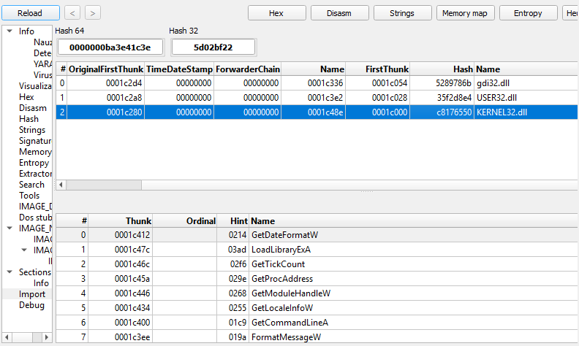
- It seems that this malware will load or unpack other APIs for the execution later somewhere. Using static analysis, we cannot obtain to much valuable information. This malware is not easy to analyze.

Dynamic Analysis
- Loading this malware into IDA, we can see the interface as below:
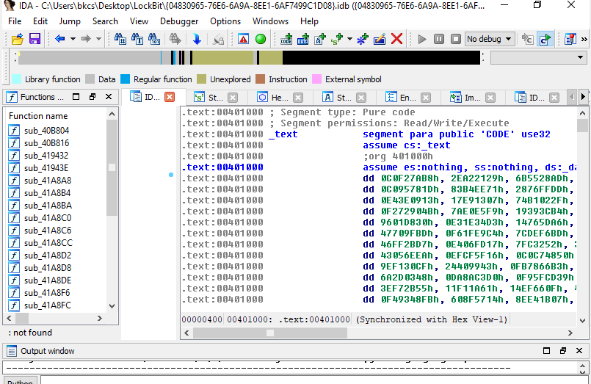
There are many functions on the left, and we cannot see and hint in the function names.

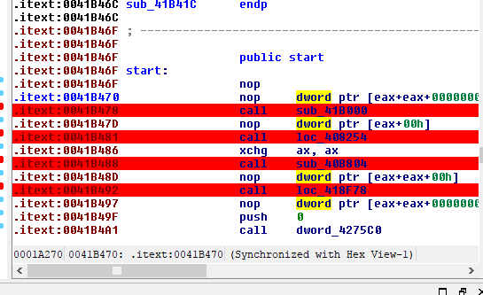
Come back to the window of IDA view. In this malware, there are four functions: sub_41B000, loc_408254, sub_40B804 and loc_418F78. The function loc_418F78 is dedicated for the ransomware main function. Let’s explore the purpose of three other functions.

Let’s look around each function and check the pseudocode of these functions. We will focus on the function sub_41B000 first.
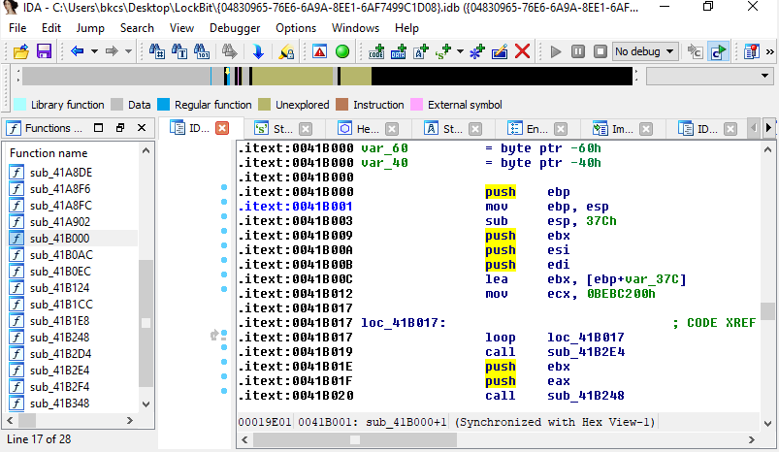
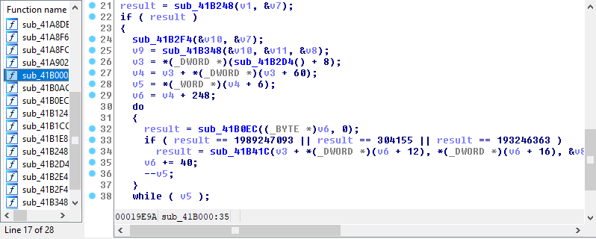
Let’s see the execution path of this function. This function will do and check something with numbers. You can also load the malware into OllyDbg to debug the code easier.
Question 2: What is the purpose of this function sub_41B000?
sub_41B000 is responsible for delayed execution and runtime unpacking/decryption of the malware payload.
Specifically, this function:
- Introduces a large delay loop (anti-sandbox / anti-emulation)
- Locates the current module in memory
- Iterates through PE sections
- Identifies specific sections by signature
- Unpack those sections into executable memory

Question 3: What is the value of number which is checked in this function?
The function checks for three specific magic values:
- 1989247093
- 304155
- 193246363
These values act as section identifiers (magic constants).
When a PE section matches one of these values, it will be selected for decryption/unpacking.

- Then, we move to the second function loc_408254.
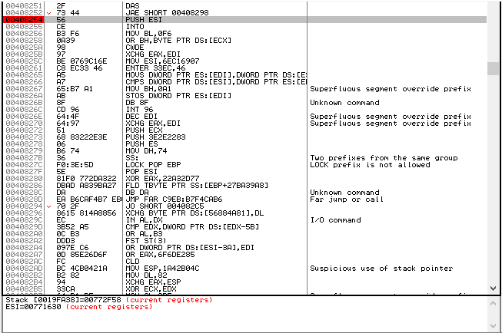
Question 4: What is the purpose of this function loc_408254?
loc_408254 is junk / anti-disassembly code used for obfuscation and anti-analysis.
This code:
- Contains invalid or rarely used instructions (into, enter, cwde)
- Mixes nonsensical operations with no meaningful logic
- Uses instructions that confuse IDA and static disassemblers
- Is not part of the real ransomware logic
Its purpose is to mislead analysts, break linear disassembly, and make reverse engineering harder.

Next, we move to next function sub_40B804.
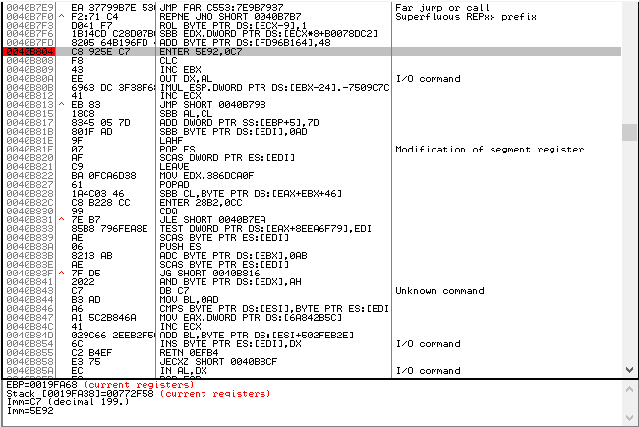

Question 5: What is the purpose of this function sub_40B804?

sub_40B804 is junk / anti-analysis code used for control-flow obfuscation.
This function:
- Contains invalid and meaningless instructions (out dx, al, unusual imul)
- Performs no useful computation
- Breaks stack analysis (enter with abnormal values)
- Redirects execution with a jump to confuse disassemblers
Its purpose is to confuse IDA and debuggers, making static analysis difficult.

After implementing these functions, the malware will call the dword_4075C0 which is dedicated for the exit process.

